**Underwater Image Enhancement and Restoration using AI & ML**

**Prof. Vivek Pandey1, Aparna Padmakumar2, Amrutha Padmakumar 3, Tejaswini Rasal4, Hitesh Khandelwal 5**

*1Prof. Vivek Pandey, Dept. of Information Technology Engineering, Armiet, Maharashtra, India*

*2Aparna Padmakumar, Dept. of Information Technology Engineering, Armiet, Maharashtra, India*

*3Amrutha Padmakumar, Dept. of Information Technology Engineering, Armiet, Maharashtra, India*

*4Tejaswini Rasal, Dept. of Information Technology Engineering, Armiet, Maharashtra, India*

*5Hitesh Khandelwal, Dept. of Information Technology Engineering, Armiet, Maharashtra, India*

----------------------------------------------------------------------------------------------------------------------------------------------------------------

**Abstract -** For the improvement and restoration of underwater photos, a fusion algorithm is suggested. Histogram stretching, contrast enhancement, and colour balancing are all done. The R, G, and B channels' scalar values are updated to make the distributions of the three channels similar in the histogram in order to lessen the impact of colour shift in an underwater image. An optimised contrast algorithm is used to establish the best transmittance rather than refining it as is done in dark channel prior based restoration.

Keywords: Restoration, Channel, Optical, modulation, Quality, Underwater, Histogram, Picture, Evaluation, Assessment, etc.

# INTRODUCTION

The undersea mission is difficult in human ocean exploration and utilisation. To complete underwater tasks including underwater item localisation, marine life recognition, underwater archaeology, underwater environment monitoring, underwater search and salvage, underwater maintenance, etc., it is essential to collect and analyse underwater data. An major source of underwater information is provided by underwater optical images. Unfortunately, underwater images captured by camera sensors are prone to deterioration because of the typical attenuation and dispersion of light in water. Attenuation typically causes a hue shift, while scattering of light blurs and reduces contrast in an underwater image. There are other factors that affect underwater visibility and the quality of underwater photographs in addition to the physical features of underwater light emission. bubbles. Marine snow causes additional light backscattering, which reduces underwater vision by producing white blobs of varied sizes and shapes in photographs. Advanced imaging tools like the multistate underwater laser line scan system or divergent-beam underwater Lidar imaging (UWLI) system can be used to capture high-quality underwater photos. The high cost of the equipment is the biggest barrier for users. The method of image processing is another option for obtaining high-quality underwater photos. It is distinguished by high efficiency and low cost.

* 1. **OBJECTIVE OF THE PROJECT**

The propagation of light differs in water and air. In the light propagation in water, there are several important factors that result in attenuation and scattering of light. The density of water is greater than air, which causes the attenuation of light. Water selectively scatters and absorbs certain wavelengths of visible light. Suspended particles in water affect the light transmission and produce scattering of light. Various types of noise occur for example marine snow that causes additional light backscattering. Temperature and salinity also cause the light scattering.

In conclusion, light attenuation and scattering in water are more severe than in air. As a result, optical images taken underwater are more likely to blur and have less contrast.

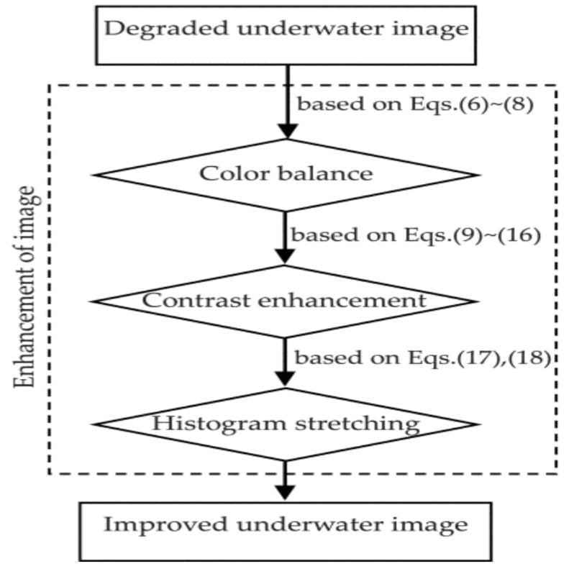

Fig 1.1 Enhancement of Image

Direct, forward-scattered, and backward-scattered components make up the three parts of the light that an underwater camera picks up. It is possible to express the entire amount of light that the camera sensor has taken in. The photos of the ocean floor can be used to research hydrothermal vents on the seafloor and to explore ideas about marine life. The main problems that an underwater image has to deal with are low contrast, colour distortion, and poor visual appeal. These issues were brought about by light's refraction and dispersion as it passed through rarer to denser material. Light refraction lessens the contrast between the colours. In addition to scattering, the existence of underwater animals also contributes to the water's influence on underwater images. Here, we present an enhanced fusion-based technique for underwater picture enhancement that can accurately restore images underwater. The proposed work uses a single image as the input and performs a series of operations on it, including white balancing, gamma correction, sharpening, and modifying weight maps. To obtain the final output, multiscale picture fusion of the inputs is completed .To remove colour casts and keep a realistic underwater image, the color-distorted input image is first white-balanced. The gamma-corrected image is subjected to CLAHE in the second stage. In order to improve the luminance of underwater photographs, CLAHE is crucial.

**MAIN PURPOSE**

Three methods are suggested to enhance the quality of underwater images: a colour balance technique, an improved contrast algorithm, and a histogram stretching approach based on the red channel. Our main goal is to create an underwater image enhancement and restoration system with reef classification that will help to reduce underwater image noise and guarantee image quality. This technique involves first removing the bright channel image from the input, which is the underwater image that has been degraded. Using the image with the greatest channel difference, correct the bright channel after that. The rectified bright channel is then used to determine the value of atmospheric light.

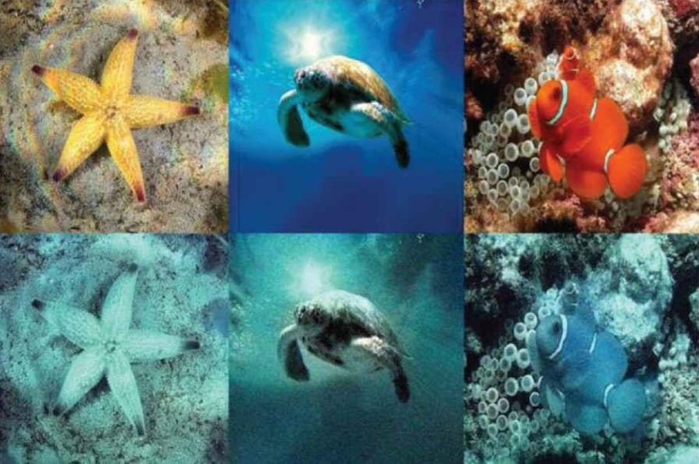

Fig 1.2 Underwater Restorated and Enhanched Images

Photographs taken underwater typically have issues with quality degradation, such as low contrast, blurred features, off-color hues, uneven lighting, etc. The repair and improvement of underwater images is essential for several practical applications and represents a significant challenge in image processing and computer vision. Underwater picture enhancement and restoration have drawn more study attention during the past few decades. However, a thorough and in-depth analysis of relevant advancements is still lacking, particularly for the underwater picture dataset analysis, which is a crucial component of underwater image processing and intelligent application. In this essay, we first provide a summary of more than 120 articles on the most recent advancements in underwater image restoration and enhancement, including the methods, data sets, programmes that can be used, and assessment criteria. We analyze the contributions and limitations of existing methods to facilitate the comprehensive understanding of underwater image restoration and enhancement. Furthermore, we provide detailed objective evaluations and analysis of the representative methods on five types of underwater scenarios, which verifies the applicability of these methods in different underwater conditions. Finally, we discuss the potential challenges and open issues of underwater image restoration and enhancement and suggest possible research directions in the future. To aid in the thorough understanding of underwater image restoration and enhancement, we examine the contributions and limits of existing approaches. Also, we offer thorough, unbiased reviews and analyses of the representative approaches on five distinct types of underwater scenarios, demonstrating their suitability for use in various underwater circumstances. Lastly, we examine the potential difficulties and unresolved problems of underwater picture improvement and offer prospective future research options.

**FUTURE SCOPE**

This project is currently in its early phases and will require additional effort in the future to be flawless. The upcoming tasks that will be completed include:

improving the testing procedures

the start of a public application

In India, artificial intelligence and machine learning have a promising future and great potential to positively impact many facets of the economy. AI comprises a variety of practical technologies, including machine learning, big data, pattern recognition, and self-improving algorithms. Soon, no sector or industry in India would be unaffected by this effective tool. This is the reason there is a rising need for online courses in artificial intelligence in India.

This project is currently in its early phases and will require additional effort in the future to be flawless. The upcoming tasks that will be completed include:

improving the testing procedures

the start of a public application

In India, artificial intelligence and machine learning have a promising future and great potential to positively impact many facets of the economy. AI comprises a variety of practical technologies, including machine learning, big data, pattern recognition, and self-improving algorithms. Soon, no sector or industry in India would be unaffected by this effective tool. This is the reason there is a rising need for online courses in artificial intelligence in India.With the development of underwater robotics, Underwater exploration has become much

easier and less onerous. But, these robots are expensive mainly because of the high end

cameras that are mounted on them. With more research in this field, we can come up with

better and robust algorithms which are camera independent.

These algorithms, when incorporated into these robots will not only aid in procuring better

enhanced underwater exploration images, but also in bring down the cost of these robots

significantly

With the development of underwater robotics, Underwater exploration has become much

easier and less onerous. But, these robots are expensive mainly because of the high end

cameras that are mounted on them. With more research in this field, we can come up with

better and robust algorithms which are camera independent.

These algorithms, when incorporated into these robots will not only aid in procuring better

enhanced underwater exploration images, but also in bring down the cost of these robots

significantly

**EXISTING SYSTEM**

The settings of the suggested model for training are first described in this section. Second, enhanced comparison findings are shown for the ablation network, DGC-UWnet, and other SOTA techniques. On the basis of the model time complexity, quantity of parameters, and processing speed, the lightweight comparative experiment is then carried out. The application test outcomes for YOLOv5l's underwater object detection are then displayed. With the aid of acoustic devices, scouring the ocean's surface for both living and non-living organisms is now a straightforward operation. One of these tools for locating the seafloor far away is side scan sonar. By emitting fan-shaped sound signals, which are then translated into images, the sonar records the scene of the ocean floor. The photographs in question are typically low contrast, grey scale, and make it difficult to see the items clearly. The suggested method divides the input image into four components, such as Low-Low, Low-High, High-Low, and High-High components, using the Stationary Wavelet Transform (SWT). The Laplacian filter is used to sharpen the low frequency component, and the LL component is subtracted from the filtered image to generate a mask. The input image is then combined with the mask to create the enhanced LL component. Inverse stationary wavelet transform, which combines the improved LL component with the other sub-bands, is used to recreate the high contrast image. By substituting the Discrete Wavelet Transform for the SWT and interpolating the frequency components, the results have been compared. The quantitative and visual results demonstrate that, in terms of contrast, the suggested method using SWT performs better than the state-of-the-art methods.

**PROPOSED SYSTEM**

The adaptive optimisation design of an optical imaging system, image transmission, picture enhancement and restoration, image retrieval, and image classification all heavily rely on image quality assessment (IQA). There are different types of objective image quality evaluation (IQE) techniques depending on whether a reference image is present. A no-reference image quality metric is required to assess the perceptual picture quality for underwater photographs for which a reference image cannot be located. Traditional objective evaluation techniques frequently fall short of assessing the quality of an underwater image because they focus on the distortion (such as Gaussian noise) of an image acquired in the air rather than the genuine mixed degradation brought on by a body of water. The performance of grayscale underwater picture enhancement and restoration has been assessed using a variety of quantitative indicators. For instance, global contrast was used by Schechner and Karpel to gauge the calibre of underwater grayscale images.

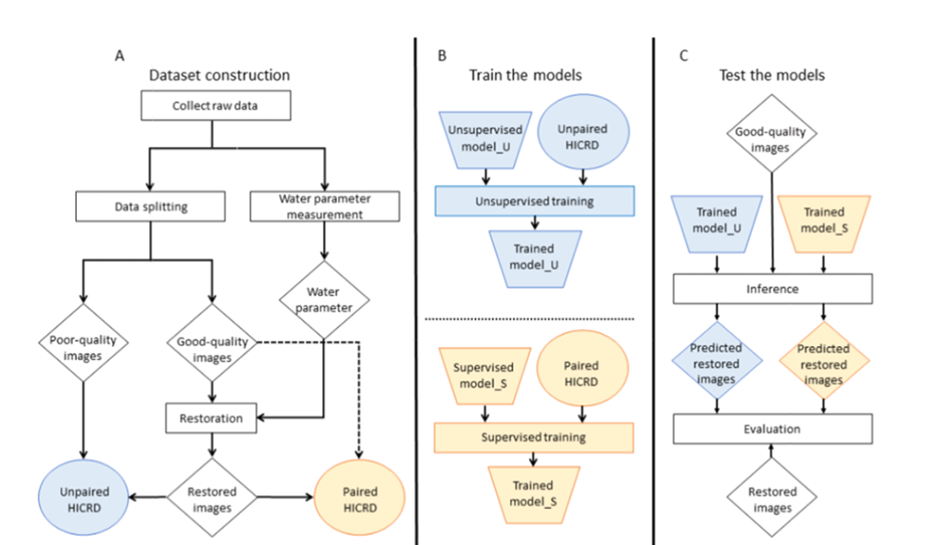

A robustness indicator was developed by Arnold-Bos et al. to assess how closely the grayscale histogram resembles the exponential distribution. Bazeille et al. also utilised this index. A method to objectively evaluate the robustness of underwater image noise removal was proposed by Arredondo and Lebart. An photograph captured in a foggy atmosphere appears to be similar to one captured in an underwater setting. To deal with underwater photos, some dehazing techniques (such DCP) are used. The outcomes, however, are unsatisfactory. The primary explanation is that different settings attenuate light in different ways. The attenuations of lights with various wavelengths are virtually same in outdoor hazy conditions. Light attenuations in aquatic environments change depending on the wavelength. shows three randomly chosen hazy pictures together with the related histograms. It is clear that the peaks, troughs, and grayscales of the histograms for the various channels—three channels for an RGB image—are remarkably similar. exhibits three randomly chosen underwater pictures in contrast, along with related histograms. As can be seen, the color deviation of the underwater . The graphics are harsh, and the contrast has significantly degraded. The single channel values that correspond to the peaks and troughs in the first two underwater photographs are different, but the peaks and troughs in each channel are equivalent. It should be noted that the third photo was taken in the dark, deep water. The longer wavelength red light is absorbed in this situation. The red channel component of the histogram likewise vanishes. It is possible to find new sources for the production of medicines, food, and energy sources, as well as renewable energy products, by solving the mysteries surrounding the deep-sea ecology.. There has been a significant increase in underwater image processing research during the past ten years.

Humans' reliance on the lucrative resources found undersea is the main cause of this. It is possible to explore the underwater world effectively by using top-notch underwater image enhancing techniques. This article's work emphasises an overview of underwater picture enhancing methods.

# ADVANTAGES OF THE PROPOSED SYSTEM

# • Improving underwater photos is crucial for examining underwater infrastructure and finding numerous man-made things.

# • There is a need to better understand marine biology and to assess the ecosystem.

# • Enhancements are employed to make imagery more easily interpreted visually and understood, and it also finds utility in the study of monuments buried in water. The ability to change an image's digital pixel values is a benefit of using digital images.

# PROBLEM DEFINITION

The advancement of underwater image processing technologies depends on underwater image collections. The datasets of underwater images utilised by researchers in the procedures of underwater picture restoration and enhancement are listed and are summarised in this section. Examples of the datasets' photos. Due to the difficulty of gathering underwater photos, there is currently no dataset that is comparatively complete. The present underwater picture collections have a number of issues, including a single target item, few categories, and inaccurate labelling data. The development of intelligent underwater image processing technologies is greatly constrained by these issues. The performance of grayscale underwater picture enhancement and restoration has been assessed using a variety of quantitative indicators. For instance, global contrast was used by Schechner and Karpel to gauge the calibre of underwater grayscale images.

# REQUIREMENT SPECIFICATION

In order to reconstruct a crisp image, approaches based on optical physical models are used to determine the imaging factors in actual underwater situations. To get clear underwater photographs, algorithms based on the optical physical model have been continuously enhanced. Serikawa employs the joint trigonometric filtering dehazing algorithm to prevent gradient back propagation artefacts. A method for mapping a nonlinear RGB image to the colour space was developed by Bianco et al. In order to repair underwater image degradation, a red channel adaptive image restoration approach is given in that calculates the red channel propagation and employs the invert channelwise equation. Some of the parameters' dependence on empirical values makes the model constraints too imprecise, which prevents the augmentation from achieving a high-quality visual sense. A method using the green channel to compensate for the red channel is proposed in light of the varied degrees to which the red-green-blue channel fades underwater. It is demonstrated that using the green channel alone is superior to using the blue channel and the green channel together. A new underwater optical physical model that differs from the one previously proposed by Zhang et al the conventional imaging model for outdoor haze. The model parameter values must necessarily be determined using empirical estimations in this procedure, yet the final plots still show a definite blue-green tint. In contrast to model-free methods, optical physical model-based underwater image enhancement techniques produce improved visual perception that is more in accordance with human vision. However, the variety in water quality and illumination, as well as optical physical models that are based on common underwater conditions, lead to instability of such approaches in unexpected scenarios.

**CONCLUSIONS**

For underwater photos with uniform or irregular illumination, we suggested a method of improvement. These circumstances often correlate to the shallow-water environment and the deep-sea environment, respectively, in practical operations. The two modules that make up the suggested methodology are color-tone correction and fusion-based descattering. The first module lessens the localised or global color-tone divergence brought on by various types of incident light. And after using the first module, the second module resolves the issues with low contrast and pixel-wise colour deviation that remained. The suggested method has been tested on photos taken in a lab and in open water at various depths and lighting levels. The proposed method performs better than many other methods in enhancing the colour balance and contrast of underwater images under various lighting conditions. It is particularly effective in enhancing the colour accuracy and information content in poorly lit areas of underwater images with non-uniform illumination, which are frequently encountered in deep-sea research and operations. Following the underwater image restoration utilising the bright channel method, I was able to produce a visually pleasing outcome by going through all the processes of research, implementation, and testing. Future research could still be enhanced by using multiple testing methods on various inputs to show the program's accuracy. Despite the variations in colour, saturation, and contrast intensities between the many applied approaches, the field of underwater image restoration has developed a number of solutions that are all effective. There hasn't been a definitive ground truth standard to refer to up until now because this field is currently undergoing development and research.

**REFERENCE**

[1] C. S. Tan, G. Seet, A. Sluzek A, et al., “A novel application of range-gated underwater laser imaging system (ULIS) in near-target turbid medium,” Optics and Lasers in Engineering, vol. 43, no. 9, pp. 995-1009, 2005.

[2] Y. W. Huang, F. M. Cao, W. Q. Jin, et al., “Underwater pulsed laser range-gated imaging model and its effect on image degradation and restoration,” Optical Engineering, vol. 53, no. 6, pp. 061608, 2006.

[3] F. R. Dalgleish, F. M. Caimi, W. B. Britton, et al., “An AUV-deployable pulsed laser line scan (PLLS) imaging sensor,” Oceans. IEEE, pp. 1-5, 2007.

[4] Z. P. Xu, H. H. Shen, Y. Yao, et al., “Direct ranging scanning laser active imaging verification system,” Optical precision engineering, vol. 24, no. 2, pp. 251-259, 2009.

[5] K. Ingrid, “Underwater Imaging and the effect of inherent optical properties on image quality,” Master thesis, Norwegian University of Science and Technology, 2012.

[6] G. Johnsen, Z. Volent, E. Sakshaug, F. Sigernes, and L. H. Pettersson, “Remote sensing in the Barents Sea,” In: E. Sakshaug, G. Johnsen, and K. Kovacs(eds.), Ecosystem Barents Sea, Trondheim, Norway, Tapir Academic Press, pp. 139-166, 2012.

[7] H. Lu, Y. Li, Y. Zhang, et al., “Underwater optical image processing: a comprehensive review,” Mobile networks and applications, vol. 22, no. 6, pp. 1204-1211, 2014.

[8] R. Schettini, S. Corchs, “Underwater image processing: state of the art of restoration and image enhancement methods,” EURASIP Journal on Advances in Signal Processing, vol. 2014, no. 1, pp. 746052, 2014

[9] M. Boffety, F. Galland, A. G. Allais, “Color image simulation for underwater optics,” Applied optics, vol. 51, no. 23, pp. 5633-5642, 2017.

[10] A. Arnold-Bos, J. P. Malkasse, G. Kervern, “Towards a model-free denoising of underwater optical images,” Oceans. IEEE, vol. 1, pp. 527-532, 2018.